Vivado
- Hardware manager > Open Target > Auto Connect
  - Right click > program
  - Bitstream: C:/proj/manta-ray/udc/artix_ila_build/system_top.bit
  - Debug: C:/proj/manta-ray/udc/artix_ila_build/debug_nets.ltx
  - Hit program
Tera Term
- Interface 0
- Setup Serial Speed: 115200

Useful Scripts in home (~) directory:
- zcu_setup.sh
  - Run this first, sets up the artix devicetree overlay and deasserts the reset signal to the artix
- udc_power_on.sh
  - Run this second, goes through and sequences the LDOs, then goes and binds the admv1320/1420 and adf4382
  - Also enables filter LDO (2.5V)
- adf4382_init.sh
  - Initializes the adf4382
- rx_tx_config.sh
  - Configures the admv1320 or 1420 depending on channel called out when using shell script (Channels: tx_0 tx_1 tx_2 tx_3 rx_0 rx_1 rx_2 rx_3)
- set_lo.sh
  - Sets LO frequency in GHz
- set_sw.sh
  - Usage: ./set_sw.sh <switch 1-4> <enable 0|1> <ctrl 0|1>
- admv8913_filter.sh
  - Usage: ./admv8913_filter.sh <HPF_freq_GHz> <LPF_freq_GHz>

Useful Registers to write:
- iio_reg admv1420_rx_n 0x28D
  - Change n to the rx channel (0 to 3), and this will read back the dsa5_bypass_value
  - Add a value to the end of the command to write a new DSA value
- 3

  - Similar but for TX, this shows DSA2 and DSA1 bypass values
Example:
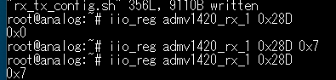
Initial Setup – Find Artix
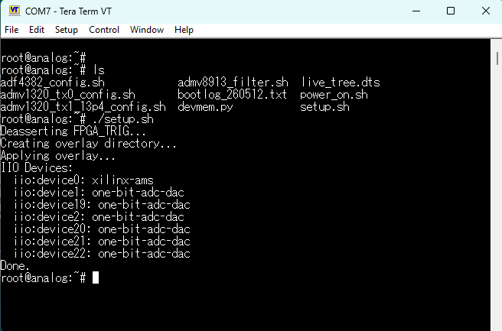
Enable LDOs (Power On)
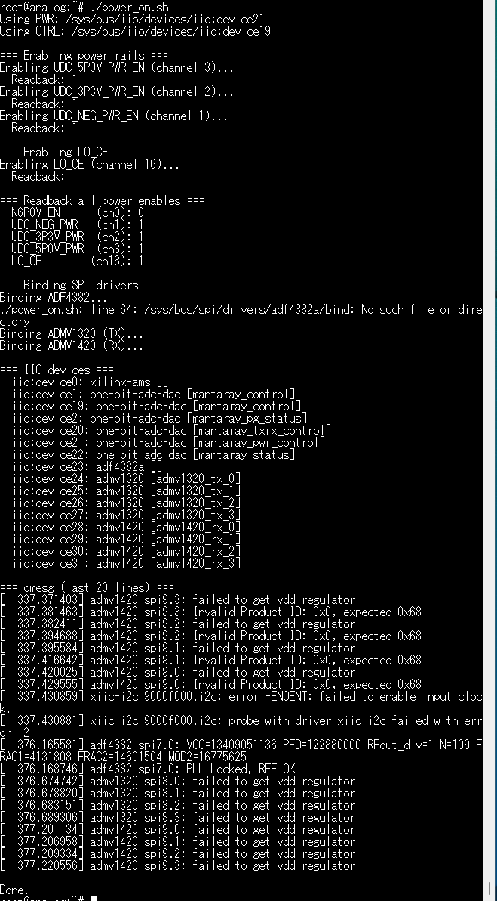

./
Filter
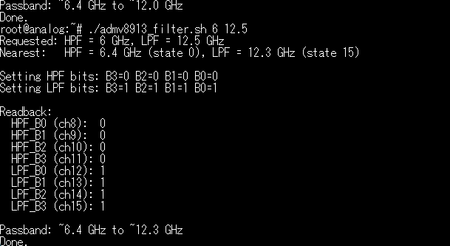
Tune Artemis Output Frequency
